# Site Co-ordinator

|  |  |
| --- | --- |
| Service: | Horizons |
| Responsible To: | Programme Manager / Head of Service |
| Salary: | Points 7-11 |

|  |
| --- |
| Job Purpose |
| To support the Management team in the day to day running of the site. Working closely with staff within Horizons and the Estates & Facilities department. |
|  |
| Main Duties |

The Site Co-ordinator will actively manage the day to day running of the Horizons North Shields building. Duties include but are not limited to:

* To provide efficient and effective service to staff and service users
* To co-ordinate the reporting of any repairs/works required
* Directing incoming traffic onto site during busy periods
* Attending to queries should they arise with a good sense of problem solving.
* To supervise contractors entering and working on site.
* To effectively handle calls appropriately and record/take messages accurately distributing accordingly;
* Ensure the signing in/out of visitors
* To undertake duties in accordance with the sites fire plans, including the preparation of fire registers
* To accompany any visitors including contractors, deliveries etc.
* To maintain accurate and accessible documentation and logs for all activities
* Setting up rooms for training, meetings etc
* To maintain work and storage areas in a neat, tidy, safe and secure manner.
* To be responsible for incoming and outgoing mail;
* To be responsible for the speedy and accurate distribution of deliveries received
* To be responsible for the maintenance and upkeep of equipment for example: photocopiers. This would include logging breakdowns and keeping equipment replenished.
* Supporting with building audits

# Person Specification

|  |
| --- |
| Essential Criteria |
| Skills and Knowledge   * Ability to empathise with the needs of disabled people * Excellent written and verbal communication skills * Knowledge of Fire Risk Assessments * An awareness about health & safety/ safe working practices * Working without direct supervision * Handle confidential information correctly * A high level of IT skills with experience of Microsoft packages * Highly organised with the ability to plan and prioritise workload to meet deadlines * Ability to present information in a professional and credible manner through effective verbal and written communication skills * Strong interpersonal skills and the ability to engage effectively with a managers and employees at all levels   Qualifications and Training   * Educated to GCSE level or equivalent, with Grade C or above in English and Maths.   Experience   * Experience in a similar role * Experience of working in a non-routine environment, with demonstrable evidence of problem solving and resolving issues as they arise (acquired through experience and/or training to Vocational level 4 or equivalent). * Experience of working in a customer facing environment, resolving queries, and using initiative to ensure first-class service delivery.   Personal Qualities   * Professional attitude and commitment to delivering a high level of service * Articulate * Self-motivated with the ability to manage your time effectively * Team worker with the ability to work independently, good teamwork and interpersonal relationships * Flexible and adaptable to meet the changing needs of the service |
|  |
| Desirable Criteria |
| Qualifications and Training   * First Aid Training   Experience   * Experience of working in a care setting. * Experience of working in an environment where compliance to standards is key |

# Organisational Standards

The Percy Hedley Foundation operates in a demanding and often changing environment. Members of staff must be flexible, adaptable, willing to face up to changing circumstances and new opportunities. The following list of duties and responsibilities must therefore be taken as a guide and is not to be comprehensive.

|  |
| --- |
| Professional Duties |
| * Participate in the review of the Foundations Policies, Procedures and Processes * Participate in arrangements for the performance development review process * Participate in arrangements for further training and professional development * Keep up to date with changes or developments within your professional area * Fully participate in the induction and training programme provided by the Percy Hedley Foundation * Contribute to the professional development of other staff, including the induction of new staff. |
|  |
| Equality and Diversity |
| * Promote equality of access to education, training, and employment opportunities for disabled people, and advocate a positive attitude * Recognise that disabled people are individuals who have specific needs * Employ support strategies that will empower disabled people * Show awareness of knowledge and display non-discriminatory behaviours at all times in relation to culture, race, ethnicity, disability, gender, sexuality, and age * Recognise the importance of inclusion by using appropriate means of communication at all times * Be flexible, trying to meet the changing needs of both disabled people and environment. |
|  |
| Discipline, Health and Safety |
| * Adhere to and promote Percy Hedley Foundation Health, Safety and Welfare policy at all times * Purchase equipment from a recognised source * Report all incidents and accidents to Health and Safety Officer * Maintain a high standard of record keeping in line with Percy Hedley Foundation policies and procedures. |
|  |
| Safeguarding |
| * Safeguarding is everyone’s responsibility. * Percy Hedley Foundation have adopted recruitment and selection procedures, and other Human Resource Management processes, that help deter, reject, or identify people who might abuse vulnerable children/adults, or are otherwise unsuited to work with them. * The Trustees/Governing Body are committed to promoting the welfare of children and young people/adults and staff are expected to ensure that the highest priority is given to following guidance and regulations to safeguard those in our care. |
|  |
| Confidentiality |
| * Respect confidentiality. All personal information about people using the foundations services to which you have access should be treated as confidential. Information about the people’s needs, progress and assessment should only be shared with the team to aid support * Remain objective and do not favour any gender, language or culture and comply with the Percy Hedley Foundation policy. |

# About Us

### We are an ambitious, entrepreneurial, and innovative charitable business working in a person-centred way to meet the needs of people with disabilities and their families. We provide a range of high-quality services and seek out opportunities to inspire and support people with disabilities to achieve their ambitions. We believe that working together as one Foundation we achieve more than individual services would achieve alone. Our influence will be regional, national & international.

### 

We are committed to safeguarding and promoting the welfare of children, young people and vulnerable adults. Applicants should be aware that the post will only be offered to successful candidates subject to an Enhanced DBS check as well as other employment clearances.

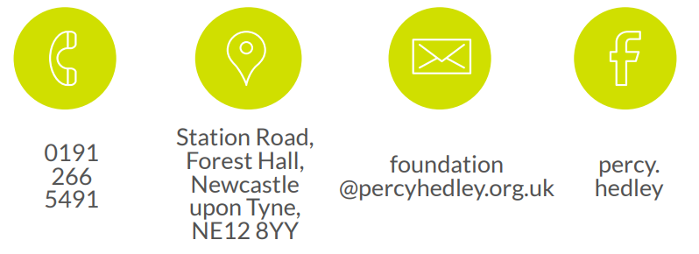

0191 238 1301

Hampeth Lodge

Station Road

Forest Hall

NE12 8YY

recruitment@

percyhedley.org.uk

<https://www.facebook.com/percy.hedley>